**CURRICULUM VITAE**

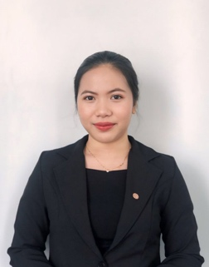**NI KOMANG KARTIKA MAHARANI**

085738522817   
[kartikamaharani58@gmail.com](mailto:kartikamaharani58@gmail.com)

Banjar Pangkung Liplip, Desa Kaliakah, Kec.Negara, Jembrana-Bali.

**PROFILE**

A Front Office student at Elizabeth Internasional Hotel and Business School that is dedicated to learning and growing in the field. Have extensive knowledge of front desk operation and handling the guest allows to craft an excellent service for the guest. Through the studies and experience, has grown into a person who never gives up and likes to learn new things. Have commitment for perfection and eagerness to learn make an asset to any hospitality industry.

**EDUCATION**

Elizabeth Internasional Hotel and Business School 2023-2024

*Front Office Major*

SMK Negeri 1 Negara 2020-2023  
*Accounting Major*

**WORK EXPERIENCES**

Amari Hotel Johor Bahru Johor Bahru, Malaysia

*Front Office Trainee*January 2024 – July 2024

Kantor Desa Kaliakah Kaliakah

*Accounting Trainee* October – December 2022

**SEMINAR & WORKSHOP**

* Build-up an Engage Correspondence Connection Upon Guests’ Pre-arrival 2023
* Guest Cycle, an Overall Hotel Guest Activities 2023
* Unlocking Success 2023

**SKILLS**

* Able to Operate Property Management System
* Able to Handling Front Desk Operation
* Able to Providing Effective Communication as Telephone Operators.
* Able to Providing Bell and Concierge Service

**ADDITIONAL SKILLS**

* Fluent English both oral and written (TOEIC skor 455)
* Able to operate Ms.Office